AI-Augmented Backend Development Project

TITLE: AI FitWell – Personalized Fitness, Wellness & Meal Planner

Description
AI FitWell is an AI-powered fitness and wellness backend application developed using Node.js, Express.js, MongoDB, and Mongoose. The project is designed to provide users with a secure platform for managing their personal fitness information, workout activities, progress records, and feedback while also providing an AI-based wellness assistant.

The application uses JWT authentication to secure user access and bcryptjs to hash user passwords before storing them. Users can register and log in, manage their fitness profile, record workouts, track progress, and submit feedback through RESTful API endpoints. The system stores these details in MongoDB using separate Mongoose models for Users, Workouts, Progress, and Feedback.

A major feature of AI FitWell is its integration with Google Gemini AI through the @google/genai package. The AI assistant provides general guidance related to workouts, nutrition, hydration, sleep, stress management, and healthy habits. The system is configured with a primary Gemini model and a fallback model to improve reliability when the primary model is temporarily unavailable.

The backend follows a modular structure with separate route files for authentication, workouts, progress, feedback, and AI chat. Environment variables are used for important configuration values such as the MongoDB connection string, JWT secret, and Gemini API key. Overall, AI FitWell combines fitness data management, secure authentication, REST API development, MongoDB storage, and generative AI into a single backend application.

Scenario
Background
AI FitWell is a fitness and wellness backend application designed to help users manage their personal fitness information, workout activities, progress records, and feedback in one centralized system. The application provides secure user authentication using JWT and bcryptjs, while MongoDB and Mongoose are used to store and manage user and fitness-related data. It also integrates Google Gemini AI to provide general wellness guidance related to workouts, nutrition, hydration, sleep, stress management, and healthy habits through an authenticated AI chat service.

Problem
- Users may find it difficult to maintain their personal fitness information in one centralized system.
- Workout activities may not be properly recorded and organized for future reference.
- Users need a structured way to maintain their fitness progress information.
- There is a need for secure user authentication to protect personal fitness data.
- Users may need general guidance related to workouts, nutrition, hydration, sleep, stress management, and healthy habits.
- A traditional fitness tracking system may not provide conversational AI-based assistance.
- Managing user accounts, workouts, progress, and feedback separately can make fitness information difficult to organize.

Solution
AI FitWell provides a centralized backend solution that combines secure authentication, fitness profile management, workout tracking, progress tracking, feedback management, and AI-powered wellness assistance. The application uses Node.js and Express.js for RESTful API development, MongoDB and Mongoose for data storage, JWT and bcryptjs for authentication security, and Google Gemini for AI-based fitness and wellness conversations.

Usage
User Usage

A registered user can create an account using the registration endpoint and securely log in using their email and password. After successful authentication, the backend generates a JWT token that authorizes access to protected APIs.
Using authenticated APIs, users can:
- Create workout records.
- View available workout records.
- Record fitness progress information.
- Retrieve their progress records.
- View and update their fitness profile.
- Submit feedback with a rating and feedback message.
- Retrieve their submitted feedback records.
- Send fitness and wellness-related messages to the AI assistant.

AI Usage
The AI module communicates with Google Gemini using a dedicated Gemini service.
Users can provide information or questions related to:
- Workouts
- Nutrition
- Hydration
- Sleep
- Stress management
- Healthy habits
- Gemini processes the user's message and provides:
- General fitness guidance
- Workout-related suggestions
- Nutrition and healthy habit guidance
- Hydration and sleep guidance
- Stress-management suggestions
- General wellness support

Outcome
AI FitWell provides a centralized backend platform for managing user fitness and wellness information through secure RESTful APIs. Users can maintain their profiles, record workouts, track progress, submit feedback, and access an AI-powered wellness assistant through the application.

The integration of Google Gemini adds conversational support for general fitness and wellness topics such as workouts, nutrition, hydration, sleep, stress management, and healthy habits. The system combines secure authentication, MongoDB data management, and AI-based assistance to provide the core backend functionality required for an AI-powered fitness and wellness application.

System Requirements :

1. Software Requirements
Operating System:
- Windows,
- Linux, or
- macOS.

Node.js (v9 or above):Node.js is used as the runtime environment for executing the AI FitWell backend application and running the Express.js server.npm (v9 or above)

Express.js: Express.js is used to develop the RESTful APIs and handle requests related to authentication, workouts, progress, feedback, and AI chat.

MongoDB: MongoDB is used as the database for storing user profiles, workout records, progress information, and feedback data.

- Postman: Postman is used to test and verify the REST API endpoints of the AI FitWell application, including authentication, workout, progress, feedback, and AI chat APIs.

- Code Editor: A code editor such as Visual Studio Code is used to develop, manage, and modify the AI FitWell backend source code and project files.

2. Hardware Requirements

- Processor: Dual-core processor or higher.
- RAM: Minimum 4 GB RAM recommended.
- Storage: Sufficient storage for the project files, Node.js dependencies, and MongoDB data.
- Internet Connection: Required for communication with the Google Gemini AI service.
- Computer/Laptop: A system capable of running Node.js, MongoDB, and development tools.

Epic 1: Project Architecture

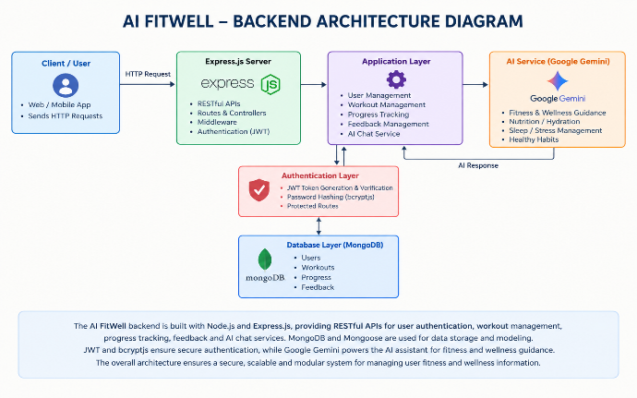

The AI FitWell follows a modular backend architecture based on Node.js, Express.js, MongoDB, and Mongoose. The application provides RESTful APIs for user authentication, profile management, workout tracking, progress tracking, feedback management, and AI-powered wellness assistance. The backend uses JWT authentication and bcryptjs for secure user access, while Google Gemini is integrated through a dedicated service for AI-based fitness and wellness guidance.

When a client sends an HTTP request, the Express.js server receives the request and forwards it to the appropriate route. Authentication middleware verifies JWT tokens for protected operations, while the route handlers perform validation, application logic, and database operations using Mongoose models. The MongoDB database stores users, workouts, progress, and feedback records. For AI chat requests, the backend communicates with the Google Gemini service and returns the generated wellness response to the client. This modular structure helps organize the application and maintain clear separation between authentication, fitness data management, database operations, and AI functionality.

Overall Architecture Components
- Client Layer
- Express.js Server
- Authentication Layer
- Route Layer
- Service Layer
- Database Layer
- AI Service

Components Definition
1.Client Layer
The Client Layer represents the external application or API testing tool that communicates with the AI FitWell backend. It sends HTTP requests to the available RESTful API endpoints and receives the corresponding responses. The client can be used to perform operations such as user registration, login, profile management, workout tracking, progress tracking, feedback submission, and AI chat.
Responsibilities
- Sends API requests.
- Provides user registration and login information.
- Sends fitness and wellness-related data.
- Sends authentication information for protected APIs.
- Displays or receives successful responses and error responses.
- Sends messages to the AI chat API.

APIs Accessed
- Authentication APIs
- Profile APIs
- Workout APIs
- Progress APIs
- Feedback APIs
- AI Chat API

2. Express.js Server
The Express.js Server acts as the central gateway of the AI FitWell backend. It receives incoming HTTP requests, loads the required middleware, connects the API routes, and sends responses back to the client.

Responsibilities
- Starts the HTTP server.
- Receives HTTP requests.
- Processes incoming request data.
- Enables CORS.
- Loads the authentication middleware.
- Registers application routes.
- Connects requests to the appropriate route handlers.

Example Responsibilities
- Receives authentication requests.
- Routes workout requests to the workout module.
- Routes progress requests to the progress module.
- Routes feedback requests to the feedback module.
- Routes AI chat requests to the AI module.

3. Authentication Layer

The Authentication Layer is responsible for securing user accounts and protected API operations. AI FitWell uses bcryptjs for password hashing and JSON Web Token (JWT) for user authentication.

Responsibilities
- Registers new users.
- Hashes user passwords using bcryptjs.
- Verifies login credentials.
- Generates JWT authentication tokens.
- Verifies JWT tokens for protected operations.
- Provides authenticated user information to protected routes.

APIs Accessed
- Register API
- Login API
- Profile API

4. Route Layer
The Route Layer organizes the backend API functionality into separate modules. AI FitWell contains dedicated routes for authentication, workouts, progress, feedback, and AI chat.

Responsibilities
- Defines API endpoints.
- Receives client requests.
- Validates request information.
- Calls the required database models or service.
- Returns responses to the client.

Route Modules
- authroutes.js
- workoutroutes.js
- progressroutes.js
- feedbackroutes.js
- airoutes.js

5. Controller Layer
The Controller Layer handles the application logic for incoming API requests. In AI FitWell, the controller responsibilities are implemented directly inside the respective route files rather than through a separate controllers folder.
Authentication Controller
Responsibilities:
- Handles user registration.
- Validates registration information.
- Hashes passwords using bcryptjs.
- Handles user login.
- Verifies user credentials.
- Generates JWT authentication tokens.
- Retrieves user profile information.
- Updates user profile information.
- Returns authentication and profile responses.
Workout Controller
Responsibilities:
- Handles workout creation requests.
- Validates workout information.
- Associates workout records with the authenticated user.
- Stores workout information in MongoDB.
- Retrieves workout records.
- Returns workout information to the client.
AI Controller
Responsibilities:
- Handles authenticated AI chat requests.
- Receives the user's wellness message.
- Passes the message to the Gemini AI service.
- Receives the generated AI response.
- Returns the AI response to the client.
- Maintains the fitness and wellness scope of the AI interaction.

6. Service Layer
The Service Layer contains functionality that supports specific backend operations and external service communication. In AI FitWell, the Gemini integration is implemented as a dedicated service, while JWT and password-related operations are handled within the authentication implementation.
Gemini AI Service
Responsibilities:
- Communicates with Google Gemini using @google/genai.
- Sends user messages to the Gemini model.
- Generates fitness and wellness responses.
- Provides guidance related to workouts and healthy habits.
- Handles nutrition, hydration, sleep, and stress-management topics.
- Uses a fallback model when the primary Gemini model returns a 503 response.

JWT Service
Responsibilities:
- Creates JWT authentication tokens during login.
- Stores the authenticated user's ID in the token.
- Sets the token expiration period to one day.
- Supports token verification through the authentication middleware.
- Protects authenticated API operations.
Implementation Note: In the uploaded AI FitWell project, JWT functionality is implemented using jsonwebtoken within the authentication route and middleware rather than as a separate JWT service file

Password Service
Responsibilities:
- Hashes user passwords before storing them.
- Uses bcryptjs for password security.
- Compares the entered password with the stored password hash during login.
- Prevents plain-text password storage.
- Supports secure user authentication.
Implementation Note: In the uploaded AI FitWell project, password operations are implemented using bcryptjs within the authentication functionality rather than as a separate password service file.

7. Database Layer
The Database Layer is responsible for storing and retrieving AI FitWell application data. The project uses MongoDB as the database and Mongoose for schema definitions and database operations.
Collections
- Users Collection
  - Stores user account information.
  - Stores fitness profile information.
  - Stores authentication-related user data.
- Workouts Collection
  - Stores workout records.
  - Stores workout name and category.
  - Stores workout duration and calories.
  - Associates workout records with users through userId.
- Progress Collection
- Stores user progress information.
- Stores weight-related records.
- Stores exercise and water-related information.
- Associates progress records with users through userId.
- Feedback Collection
- Stores user feedback.
- Stores feedback ratings from 1 to 5.
- Stores feedback messages.
- Associates feedback records with users through userId.

Advantages
- Provides centralized storage for fitness and wellness data.
- Separates different types of application data into dedicated collections.
- Uses Mongoose schemas for structured data validation.
- Maintains relationships between users and their fitness records through userId.
- Provides persistent storage for user, workout, progress, and feedback information.

ER Diagram

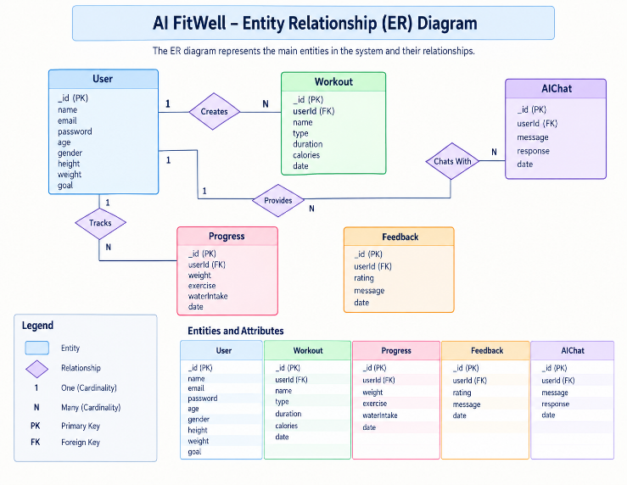

1. User Entity
The User Entity stores the authentication and fitness profile information of AI FitWell users. It contains the details required for user registration, login, profile management, and personalized fitness information.

Field | Type | Description
_id | Object Id | Primary Key
Name |  | User Name
  String
Email |  | Unique Email Address
  String
Password |  | Hashed Password
  String
Age |  | User Age
  Number
Gender |  | User Gender
  String
Height |  | User Height
  Number
Weight |  | User Weight
  Number
Fitness Goal |  | User Fitness Goal
  String
Activity Level |  | User Activity Level
  String
Dietary Preference |  | User Dietary Preference
  String

Constraints
- Email must be unique.
- Password is encrypted using bcryptjs.
- Name is mandatory.
- Password must satisfy the minimum length requirement.
- JWT token is generated after successful login.
- User authentication is required for protected operations.

2. Workout Entity
The Workout entity stores workout-related information for each authenticated user.
Field | Type | Description
_id | ObjectId | Primary Key
userId | ObjectId | References User
workoutName | String | Workout Name
category | String | Workout Category
duration | Number | Workout Duration
calories | Number | Calories Burned
date | Date | Workout Date

Relationship
User → Workout
Relationship Type: One-to-Many

Workout Constraints
- userId is required.
- workoutName is required.
- category is required.
- duration must be at least 1.
- calories must be 0 or greater.
- The workout date is automatically assigned when the record is created.

Key Features
AI FitWell provides a complete backend solution for fitness and wellness management with secure authentication, workout tracking, progress management, feedback management, and AI-powered wellness assistance.

1.Secure Authentication

The application implements JWT-based authentication.
Features include:
- User Registration
- Secure Login
- Password Hashing using bcryptjs
- JWT Token Generation
- Protected APIs
- User Profile Management

2. Workout Management

Users can create and retrieve workout records through the RESTful API.
Supported Operations
- Add Workout
- View Workout Records
- Store Workout Name
- Store Workout Category
- Store Workout Duration
- Store Calories
- Store Workout Date
Each workout is linked to its authenticated user through userId.

3. Workout Search

The current AI FitWell project does not contain a separate workout search API.

Implemented functionality includes:
- Create Workout
- Retrieve Workout Records
- Associate Workouts with Users
Search by workout name, category, or date is not implemented in the uploaded project.

4. Google Gemini Integration

The application integrates Google Gemini through the @google/genai package.
Features include:
- AI Chat Functionality
- Google Gemini Integration
- Fitness and Wellness Guidance
- Dedicated Gemini Service
- Fallback Model Support

5. AI Fitness Insights

The AI assistant provides general fitness and wellness guidance.
Supported areas include:
- Workout Guidance
- Nutrition Guidance
- Hydration Guidance
- Sleep Guidance
- Stress Management
- Healthy Habits
The AI is instructed not to diagnose medical conditions and to direct serious medical concerns to qualified healthcare professionals.

6. Centralized Error Handling

The uploaded AI FitWell project does not contain a separate centralized error-handling module.
Error handling is performed within the implemented application logic for:
- Authentication Errors
- Validation Errors
- Database Operations
- AI Service Responses
- Invalid Requests

7. RESTful API Design
The application provides RESTful APIs for communicating with the backend.
API Modules include:
- Authentication APIs
- Profile APIs
- Workout APIs
- Progress APIs
- Feedback APIs
- AI Chat API

8. Modular Architecture
The application follows a modular backend structure.
Modules include:
- Authentication Routes
- Workout Routes
- Progress Routes
- Feedback Routes
- AI Routes
- Authentication Middleware
- Mongoose Models
- Gemini AI Service
This structure keeps the major application functionalities separated and makes the backend easier to maintain and extend.

Roles and Responsibilities

The AI FitWell backend supports one primary role.

Authenticated User

Responsibilities
- Register an account.
- Login securely.
- View profile information.
- Update profile information.
- Add workout records.
- View workout records.
- Add progress records.
- View progress records.
- Submit feedback.
- View submitted feedback.
- Send fitness and wellness messages to the AI assistant.
- Receive AI-generated fitness and wellness guidance.

Permissions
 | Permission
  Operation
Register | Yes
Login | Yes
View Profile | Yes
Update Profile | Yes
Add Workout | Yes
Get Workouts | Yes
Add Progress | Yes
Get Progress | Yes
Submit Feedback | Yes
Get Feedback | Yes
AI Chat | Yes

User Flow
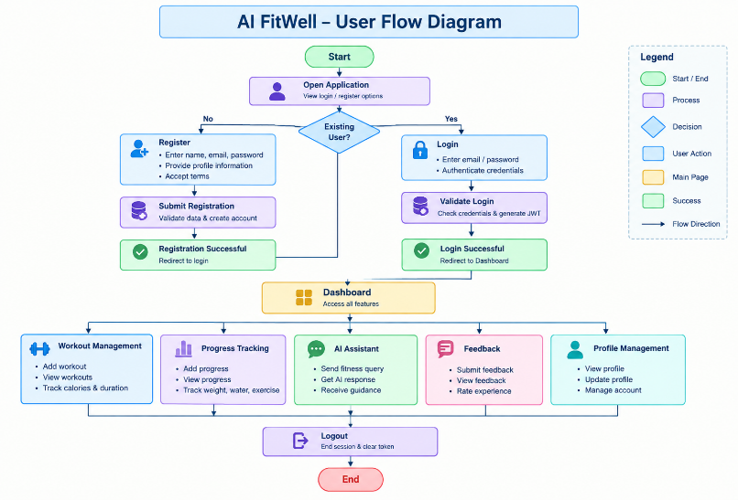

MVC Architecture Pattern

The AI FitWell backend follows the Model–View–Controller (MVC) architecture pattern to organize the application into separate functional responsibilities. This structure helps manage user authentication, fitness data, database operations, and AI services in a modular manner.

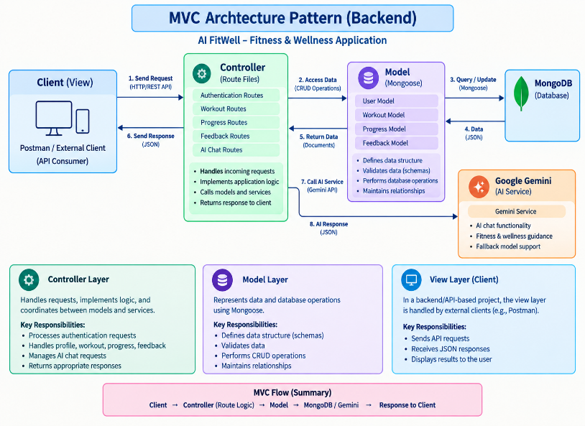

1.Model Layer

The Model Layer represents the data structure and database operations of the application. AI FitWell uses Mongoose models to define schemas and communicate with MongoDB.

Models include:

- User Model
- Workout Model
- Progress Model
- Feedback Model

Responsibilities:

- Defines the structure of application data.
- Validates stored data using Mongoose schemas.
- Creates and retrieves database records.
- Maintains relationships between users and their fitness records.

2. View Layer

Since AI FitWell is a backend/API-based project, it does not contain a separate frontend View layer in the uploaded project. The API responses act as the interface through which an external client or Postman communicates with the backend.

Responsibilities:

- Receives JSON responses from the backend.
- Displays API results through the client or API testing tool.
- Sends requests to the available RESTful APIs.
- Presents successful or error responses to the API consumer.

3. Controller Layer

The Controller Layer handles incoming API requests and application logic. In the AI FitWell project, controller functionality is implemented directly inside the respective route files rather than through a separate controllers folder.

Responsibilities:

- Processes authentication requests.
- Handles profile operations.
- Processes workout requests.
- Handles progress and feedback operations.
- Processes AI chat requests.
- Communicates with models and the Gemini service.
- Returns appropriate responses to the client.

Epic 2: Project Setup and Configuration

The AI FitWell project follows a modular backend architecture that separates authentication, fitness data management, database operations, middleware, and AI services into different modules. This structure improves code organization, maintainability, and ease of development.

The backend is developed using Node.js and Express.js, with MongoDB as the primary database and Google Gemini AI for fitness and wellness assistance.

Creating Project Folder

step 1: Create the Project Folder
Create a new folder with the project name:

AI-FitWell

This folder contains the complete backend project and its related configuration files.

Step 2: Open the Project
Open the AI-FitWell project folder in a code editor such as Visual Studio Code.

The project can then be managed through the editor's file explorer and integrated terminal.

Step 3: Create the Server Folder

Inside the project directory, create a folder named:

Server

The backend source code and server-related files are maintained inside this folder.


Step 4: Initialize the Node.js Project

Open the terminal inside the server folder and initialize the Node.js project.
This creates the package.json file, which maintains the project's dependencies and configuration.

Step 5: Install Required Packages

Install the packages required for AI FitWell backend development:

- express – Backend web framework.
- mongoose – MongoDB database interaction.
- bcryptjs – Password hashing and verification.
- jsonwebtoken – JWT-based authentication.
- dotenv – Environment variable management.
- cors – Cross-Origin Resource Sharing.
- @google/genai – Google Gemini AI integration.

Environment Variables
Sensitive configuration information is stored in the .env file.

Example:

MONGODB_URI=your_mongodb_connection_string

JWT_SECRET=your_jwt_secret_key

GEMINI_API_KEY=your_google_gemini_api_key
Using environment variables improves security by preventing sensitive configuration information from being directly exposed in the source code.

Epic 3: Backend Development
Backend development focuses on implementing the RESTful APIs that provide the core functionality of the AI FitWell application. The backend is developed using Node.js and Express.js and connects with MongoDB through Mongoose for storing and retrieving application data.

The project is divided into multiple modules that collectively perform authentication, profile management, workout management, progress tracking, feedback management, and AI-powered wellness assistance.

Major modules include:

- Server Configuration
- Database Configuration
- User Authentication
- User Profile Management
- Workout Management
- Progress Management
- Feedback Management
- Google Gemini AI Integration
- Authentication Middleware
- RESTful API Routes
- Environment Configuration

The backend processes client requests through the appropriate route modules, performs the required operations using Mongoose models or the Gemini AI service, and returns the corresponding response to the client.

Video link: https://drive.google.com/drive/folders/12ncFL4FrhvhADoLMVTh3liyNBVfX8lnE?usp=sharing

Epic 4: Database Configuration

The AI FitWell backend uses MongoDB as its primary database for storing user and fitness-related information. Mongoose is used as the Object Data Modeling (ODM) library to define schemas, validate data, and perform database operations between the Node.js application and MongoDB.

The database layer manages the persistent storage of user profiles, workout records, progress information, and feedback submitted through the application

MongoDB Configuration

MongoDB stores AI FitWell application data as collections containing document-based records. The application uses Mongoose models to define the structure and validation rules for each type of data stored in MongoDB.

Database Collections

- Users Collection
- Workouts Collection
- Progress Collection
- Feedback Collection
Each collection stores documents related to a particular application function. User-related fitness records are associated with the corresponding user through the userId field where applicable.

Installing Mongoose

Mongoose is used as the bridge between the Node.js application and MongoDB. It provides schema definitions, validation, and methods for creating and retrieving database records.

npm install mongoose

Mongoose helps the AI FitWell application maintain structured data while communicating with the MongoDB database.

MongoDB Connection

The MongoDB connection is established when the AI FitWell server starts. The application uses the MONGODB_URI environment variable to obtain the MongoDB connection string and connects to the database through Mongoose.

Responsibilities

- Connect the backend application to MongoDB.
- Use the configured MONGODB_URI connection string.
- Establish the database connection when the server starts.
- Report database connection errors.
- Provide the database connection required by the application models.

Advantages
- Provides persistent storage for application data.
- Separates data into dedicated collections.
- Mongoose provides schema-based data validation.
- Simplifies communication between Node.js and MongoDB.
- Supports structured storage of users, workouts, progress, and feedback.
- Allows application data to be retrieved through Mongoose models.

Mongoose Schemas
The AI FitWell backend uses Mongoose schemas to define the structure and validation rules for data stored in MongoDB. The main schemas relevant to user authentication and workout management are the
1.User Schema and
2.Workout Schema.

1. User Schema (models/user.js)

The User Schema stores user authentication details and personal fitness profile information. It defines the fields required for registration, login, and profile management.

Validation Rules

- name is required.
- email is required and must be unique.
- Email is stored in lowercase format and trimmed.
- password is required.
- Password must contain a minimum of 6 characters.
- age must be a valid number when provided.
- height must be a valid number when provided.
- weight must be a valid number when provided.
- Passwords are hashed using bcryptjs before storage.

User Schema Features

- Stores user account information.
- Stores personal fitness profile details.
- Supports secure password storage.
- Maintains a unique email address for each user.
- Stores fitness goal information.
- Stores activity level information.
- Stores dietary preference information.
- Supports user profile retrieval and updating.

2. Workout Schema (models/workout.js)

The Workout Schema stores workout-related information created by users. Each workout record is associated with a user through the userId field.

Validation Rules

- userId is required.
- workoutName is required.
- category is required.
- duration must be at least 1.
- calories must be 0 or greater.
- date is automatically assigned when a workout record is created.

Workout Schema Features

- Stores the name of the workout.
- Stores the workout category.
- Stores workout duration.
- Stores calories burned.
- Associates each workout with a specific user.
- Automatically records the workout date.
- Supports storing and retrieving workout records through MongoDB.

Epic 5: Project Execution

- Install Postman for API testing.
- Start the AI FitWell backend server:
“npm start”

API Testing

API testing ensures that each AI FitWell endpoint functions correctly and returns the expected response. The AI FitWell backend can be tested using Postman, allowing developers to verify request handling, authentication, database operations, and Google Gemini AI integration.

Testing is performed in the following order:

- Authentication APIs
- Profile APIs
- Workout APIs
- Progress APIs
- Feedback APIs
- AI Chat API

Authentication API Testing

Register User
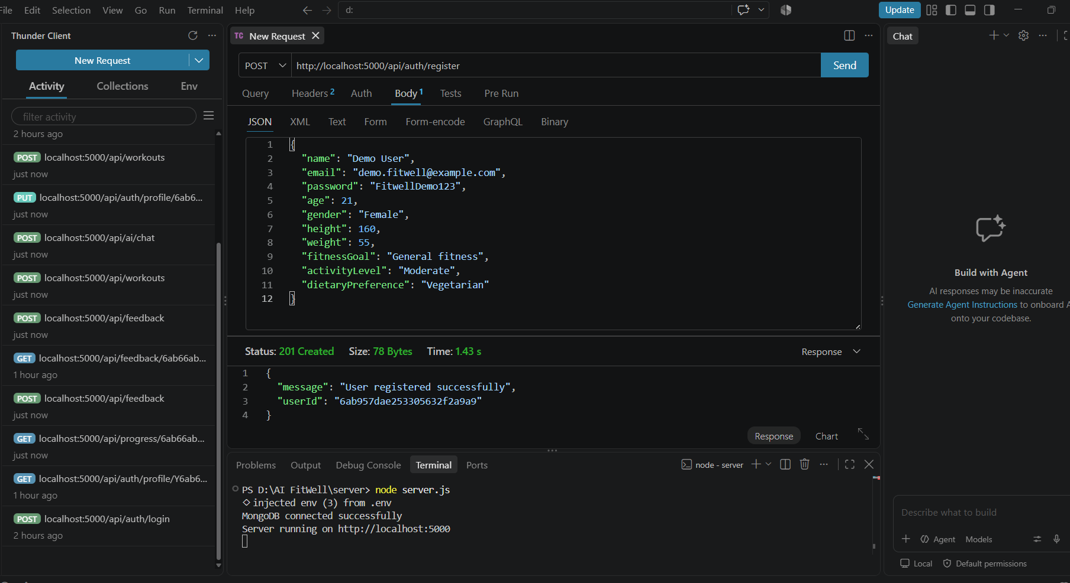Login User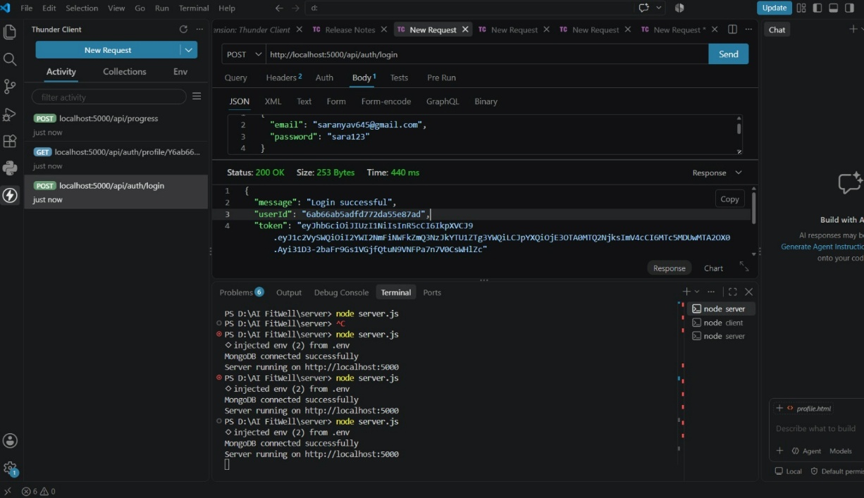

Get Profile

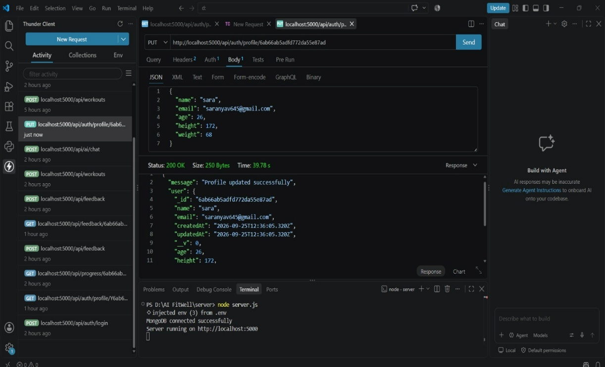

Workout API Testing

Add Workout

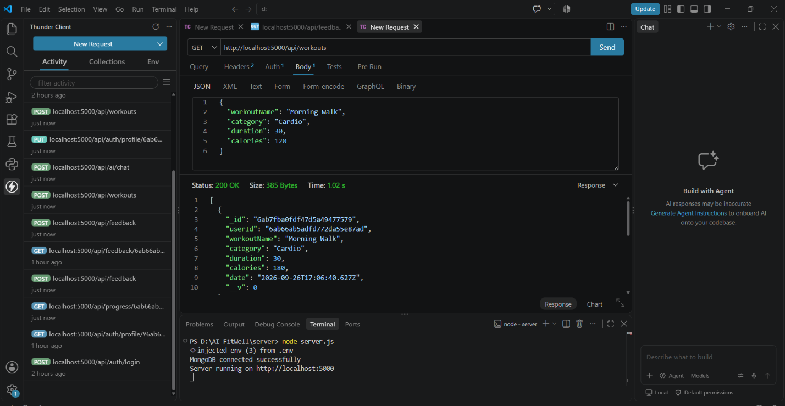

AI API Testing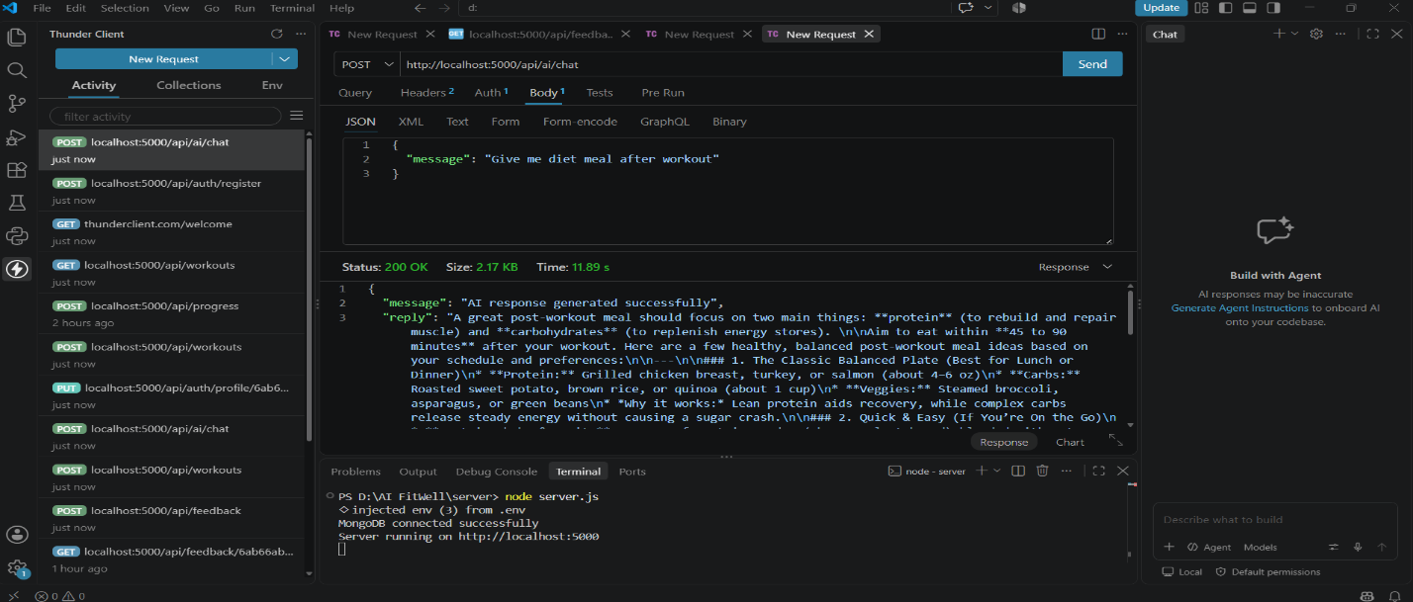

Workout Recommendation

API Submit feedback

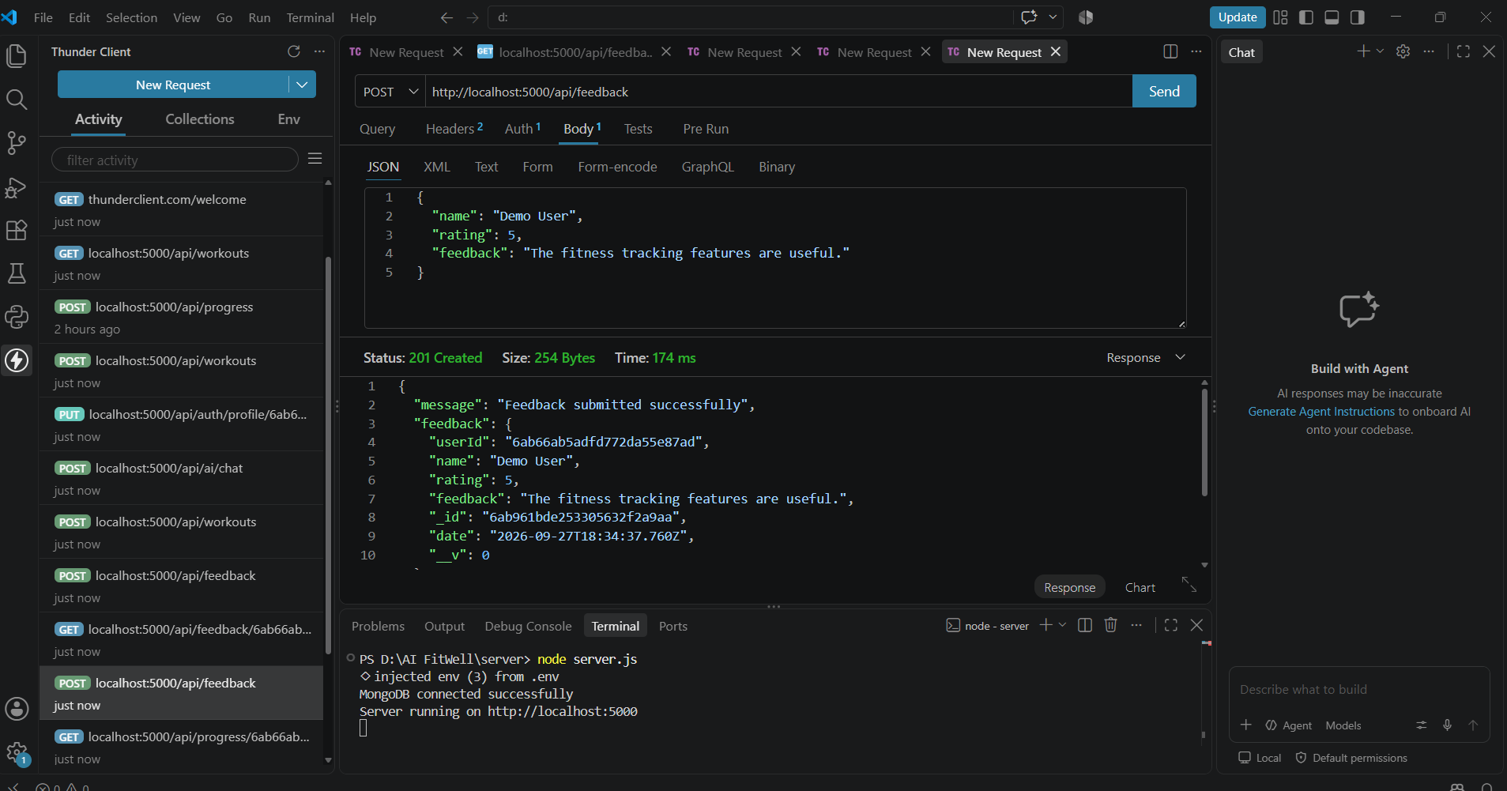

API Save fitness progress

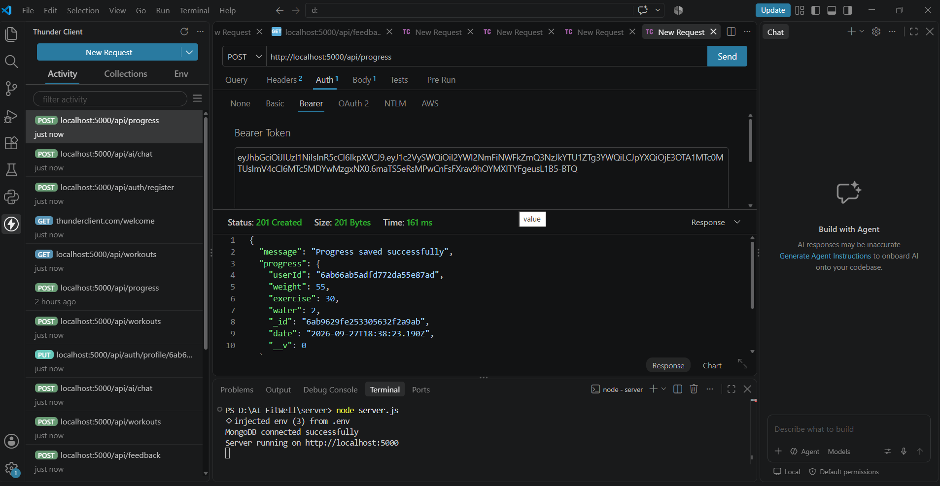

Demo Video Link: https://drive.google.com/drive/folders/12ncFL4FrhvhADoLMVTh3liyNBVfX8lnE?usp=sharing

API TESTING VIDEO: https://drive.google.com/file/d/1mwnFbzL4CIOrcG8G5NpNFCk52y_2xykZ/view?usp=sharing

CodeDrive: https://drive.google.com/drive/folders/12ncFL4FrhvhADoLMVTh3liyNBVfX8lnE?usp=sharing

